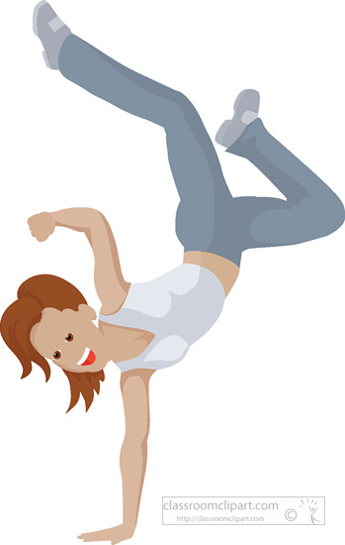
Adult Dance Party – Session 1
Hip Hop for Beginners
Starting Wednesday, Oct. 4 – Nov. 15
8:30-9:15 pm
Cost $49
($7 per class!)
All you need is comfortable clothes & a water bottle!

Class limited to 12 participants
Fill out a registration form and drop off your class fees at the desk!

